Investigation of Asian Options
Benjamin Alioni, Cory Peters, Sidney Washburn

Introduction
Asian options are an exotic style of option where the payoff at expiration is given by the average of the asset price over the life of the contract, rather than the asset price at expiration as in vanilla European or American options. This averaging dampens the impact of volatility, as seen in the figure below taken from Monte_Carlo_Methods.ipynb for a sample stock path with σ = 0.41, initial stock price 250 and strike price 240.
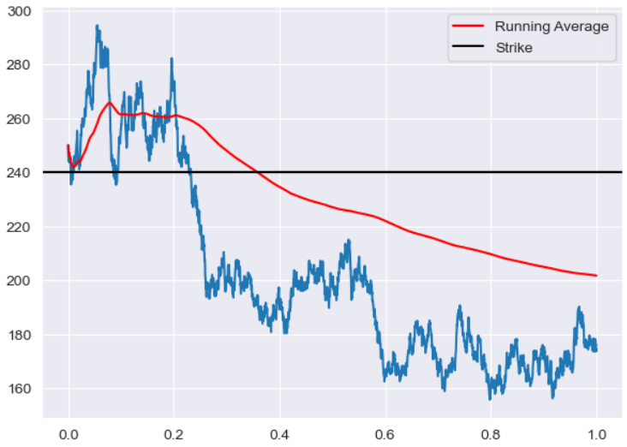
Because of the reduced volatility, Asian options have smaller premiums than vanilla options and offer traders reduced exposure to market volatility. For example, Asian options are traded for crude oil because oil is traded in high volumes and prices are prone to sudden jumps in price and volatility due to global events, as seen below.
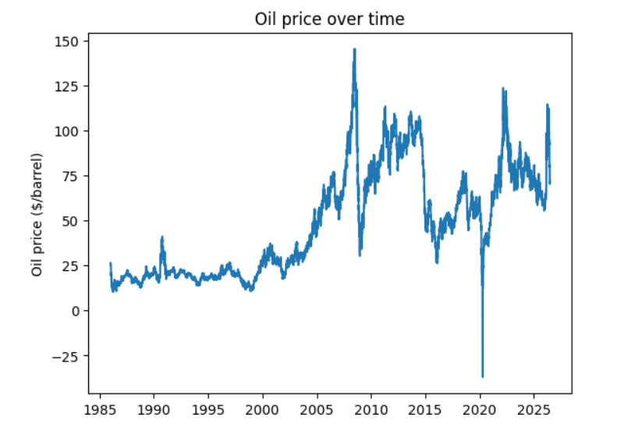 | 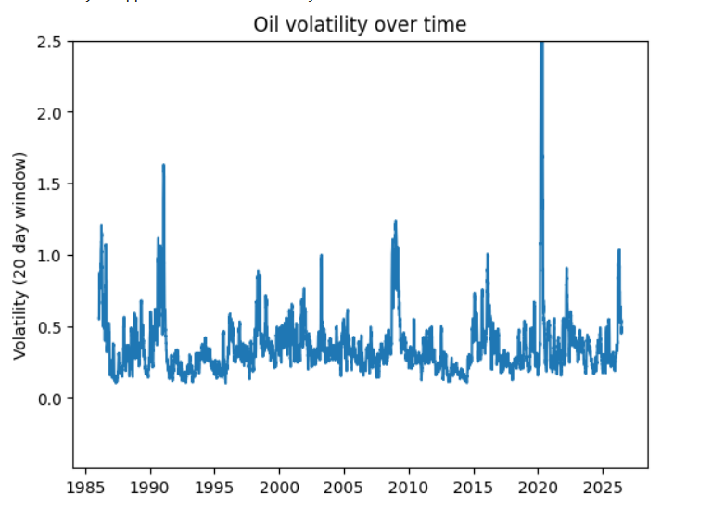

Methods
Asian options are more difficult to price than vanilla options because there is no closed-form solution as for European options, and the path dependence which eliminates lattice methods such as the Cox-Ross-Rubinstein method. We calculated the price of Asian options in two different ways.
- We used a Monte Carlo approach, modeling stock trajectories as geometric Brownian motion. From this, we were able to price the option as the discounted value of the expectation of the value at maturity.
- The value of an Asian option can be modeled by the Večeř partial differential equation. We then used numerical methods to solve this PDE. Specifically we used an implicit Euler finite-difference scheme to discretize the equation.
- We also used Monte Carlo methods to estimate the Deltas of Asian Calls via pathwise estimation.

Key Findings
Asian calls are consistently cheaper than European calls with the same strike price. The amount by which they are cheaper depends on the maturity time and the volatility. Likewise, the Greeks for both are comparable in magnitude. (The cutoff axis should say “Strike Price/S_0” in the figure below.)
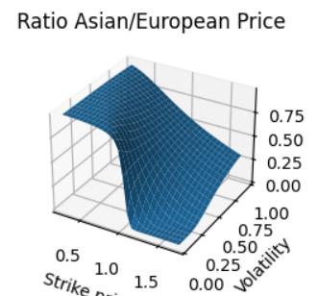

Delta hedging a portfolio consisting of Asian calls gives similar results as Delta hedging in the European counterpart; more hedging removes extreme losses and smooths the profit distribution towards the average.
